**ECRAN Component 3 Climate Action. Emission Trading Working Group. Sub Task 3.3.1**

**Regional Training on inclusion of aviation into the EU Emission Trading Scheme, with focus on the Monitoring and Reporting, and Accreditation and Verification Regulations for Regional Aircraft Operators**

10th and 11th April 2014

Venue tbd, Istanbul, Turkey

**Background to ECRAN**

The European Commission has been supporting climate cooperation in the region of the Western Balkans and Turkey, first with the Regional Environmental Network for Accession (RENA), and now with the Environment and Climate Regional Accession Network (ECRAN). The climate component of ECRAN will focus on sharing EU experiences to facilitate the development of national climate policies converging with EU *acquis*, including capacity building on emissions trading.

During the predecessor programme of ECRAN (RENA), the EU Emissions Trading System Working Group (EU-ETS Working Group) targeted the competent authorities as the primary target group. However, in order to have a future sound Monitoring, Reporting and Verification (MRV) system in place it is necessary to expand this target group and to start working with the operators and other relevant authorities under the motto: “Poor quality applications for permits or monitoring plans (MPs) will lead to poor quality permits and/or MPs; High quality applications for permits or MPs will lead to high quality permits/MPs”.

Preparations by the beneficiaries for future EU ETS involvement should be supported, in particular through specific MRV-related trainings.In this contextcompetent authorities and operators of installations as well as aircraft operators and potential verifiers must be provided with the necessary capacity, knowledge and competence to fulfil, within the appropriate time-frames and on a permanent basis, the requirements under the directive.

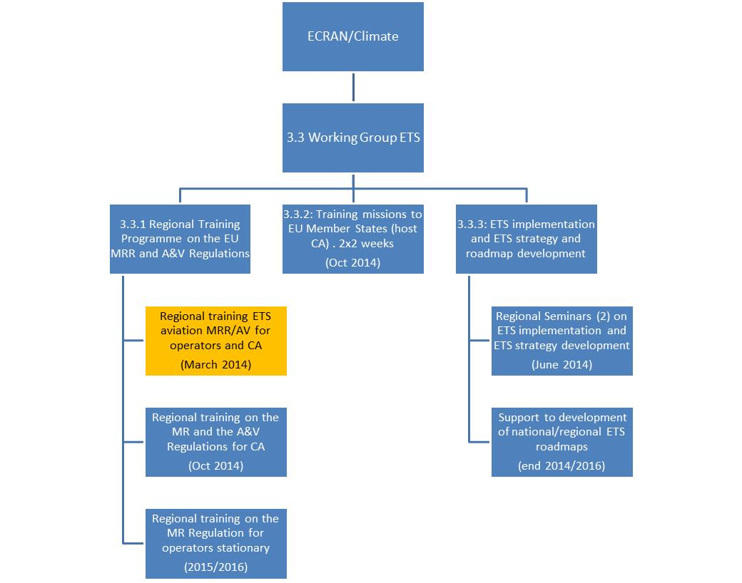

The Emissions Trading Working Group’s objective is to provide the essential regulatory building blocks and to increase technical capacity for a functioning future national or regional ETS system, which could be modelled in line with the EU ETS. This could pave the way for further cooperation and linking with the EU ETS.

The following results are expected for this Working Group:

* To improve technical understanding of the ETS implementing provisions in relation to monitoring, reporting, verification and accreditation (MRVA) in the beneficiary countries, among the target group of industry and aircraft operators, as well as the competent authorities and potential verifiers.
* To identify institutional, legal and procedural arrangements for a future national or regional ETS system which could be modelled in line with the EU ETS.

**Training programme on the EU Monitoring and Reporting, and Accreditation and Verification Regulations**

A regional training programme on the EU Monitoring and Reporting, and Accreditation and Verification Regulations (MRR and AVR) will support operators of industrial installations, aircraft operators, authorities and verifiers on the basis of guidance and templates that have been developed by the European Commission. The following activities are planned under ECRAN:

1. Regional aircraft operators training (this training)
2. Regional training on the MRR and the AVR (September 2014, Zagreb). The main target groups are the competent authorities from the region.
3. Regional trainings on the MRR. Technical trainings targeted mainly at the operators of stationary ETS-like installations (2015/2016).

**Background to the inclusion of aviation in ETS**

Direct emissions from aviation account for about 3% of the EU’s total greenhouse gas emissions. The large majority of these emissions stem from international flights. By 2020, global international aviation emissions are projected to be around 70% higher than in 2005 even if fuel efficiency improves by 2% per year. The International Civil Aviation Organisation (ICAO) forecasts that by 2050 emission from air traffic could grow by a further 300-700%.

Since the beginning of 2012, emissions from international aviation have been included in the EU Emissions Trading System (EU ETS). In September 2013 the ICAO Assembly took the decision to develop a global market-based mechanism (MBM) by 2016 addressing international aviation emissions and with an implementation date of 2020. Until then, countries or groups of countries, such as the EU, are allowed to implement interim measures. In response to the ICAO decision and in order to give further momentum to the global discussions, the European Commission has proposed amending the EU ETS directive as follows:

* Emissions from flights between airports in the European Economic Area (EEA, covering the 28 EU Member States plus Norway and Iceland) would continue to be covered.
* Emissions from flights to and from countries outside the EEA would be fully exempted for 2013.
* From 1 January 2014, flights to and from countries outside the EEA would benefit from a general exemption for the proportion of emissions that take place outside EEA airspace. Only the emissions from the proportion of each flight taking place within EEA airspace would be covered.
* To accommodate the special circumstances of developing countries, flights between the EEA and least developed countries, low-income countries and lower-middle income countries which benefit from the EU's Generalised System of Preferences and have a share of less than 1% of international aviation activity would be fully exempted from the EU ETS.

**Objective of this training**

The objective of the training is an improved technical understanding of the ETS implementing provisions in relation to monitoring, reporting, verification and accreditation in the beneficiary countries among the target group of aircraft operators, as well as competent authorities and potential verifiers. In addition, information will be provided on the requirements of the MRR and the AVR, as well as the guidance and templates that have been developed to support a harmonised implementation and compliance with the EU ETS.

**Agenda of the training**

The issues to be addressed in the training are the following:

* The EU ETS Directive with a special emphasis on the inclusion of aviation into the EU-ETS
* The Compliance cycle: Tasks of aircraft operators; role of competent authorities; European Commission; verifiers; and the national accreditation bodies
* Monitoring and reporting of tonne-kilometre data
* Monitoring plan for the emissions and the use of the MP templates
* Monitoring plan for the tonne-kilometre data - templates
* Verification for EU ETS aviation - explanation of the verification template
* Verification of small emitters and the use of the EUROCONTROL’s small emitter’s tool
* Data collection by EUROCONTROL and provision of this data to support compliance with EU ETS
* Best practice examples from the EU Member States

For further information please see: <http://ec.europa.eu/clima/policies/transport/aviation/>

**Target groups for the training**

The main target groups in the region are:

1. The registered aircraft operators (airlines / aircraft management companies / private operators)
2. The (potential) competent authorities
3. The accredited and potential verifiers
4. Other stakeholders (traders, airports, civil society organisations, consulting firms etc.)

**Expected results of the training**

The participants will acquire:

1. Detailed knowledge of EU ETS legislation and its compliance processes relevant for aviation
2. Practical understanding of the mechanisms and requirements of the EU ETS and their implications for aircraft operators, verifiers and regulators

**Speakers and trainers**

* Eve Tamme, European Commission, DG Climate Action
* Imre Csikós, ECRAN, Team Leader ECRAN Climate Action
* Monique Voogt, ECRAN, coordinator work group ETS
* Chris Dekkers, ECRAN
* Saviour Vassallo (MT) Senior Environment Protection Officer - Climate Change Malta Resources Authority
* Renée Peerboom, representative of the Dutch Emissions Authority (NEa)
* Charalambos Savvidis, representative of the German Emissions Authority – DEHSt
* Madlena Ožanić, representative of the Croatian Ministry of Environment and Nature Protection
* Stefano Mancini, EUROCONTROL
* Michael Kluge, Sr. Director Aviation Regulatory & Compliance Affairs of DHL Germany

**Further information on the workshop**

The workshop will be held in Istanbul on 10 and 11 April 2014. We kindly invite you to nominate **up to five key experts** in your country that **are already** or **could be** involved in the application of the MRVA requirements of the EU ETS system. In addition we encourage the participation of the **aircraft operators** registered in the ECRAN beneficiary countries to allow them to be updated on the newest developments and to receive practical training on the EU –ETS and its MRVA requirements.

The workshop is organised in collaboration with the Technical Assistance and Information Exchange (TAIEX) instrument managed by the Directorate-General for Enlargement of the European Commission Logistical arrangements for the nominated beneficiary representatives and the TAIEX experts will be provided in line with the standard Manual of Procedures for TAIEX Operations

Focal Points are required to submit the names of their representatives to the ECRAN Secretariat who will communicate the final list of participants to TAIEX.

**We believe that the workshop provides an opportunity not only for knowledge and experience sharing on the EU ETS, but also for further enhancing cooperation and promoting positive change.** Let's all learn and maximise our efforts fighting climate change.

Hereafter please find the Agenda attached.

Yours sincerely

Imre Csikós

**Draft training agenda**

**Thursday 10th April 2014 (Day 1 of training)**

* The 1st day will provide a background and rationale for the inclusion of aviation in the EU ETS, addressing the key role of aviation in global GHG mitigation efforts, and the important role of EUROCONTROL in providing the basic data for EU ETS compliance of the aviation industry, as well as the practical experience of an aircraft operator in complying with EU ETS. EU ETS regulation and guidance are presented together with the various templates developed to assist in the compliance cycle.
* The time allocated to the presentations include time for Q&A (at least 15 min).

|  |  |  |  |  |
| --- | --- | --- | --- | --- |
| **Venue: tbd, Istanbul** | | | | |
| **Start** | **Finish** | **Topic** | **Speaker** | **Sub topic/Content** |
| **08:30** | **09:00** | **Registration** | | |
| 09.00 | 09.15 | Formal opening, word of welcome, and presentation ETS/aviation in Turkey | Deputy Undersecretary Professor Mehmet Emin Birpinar, Ministry of Environment and Urbanisation |  |
| 09.15 | 09.30 | Round of introduction participants |  |  |
| 09.30 | 09.45 | Introduction to ECRAN | Imre Csikós, ECRAN | * Introduction to ECRAN |
| 9.45 | 10.00 | ECRAN Climate Working Group and introduction to training | Monique Voogt, ECRAN | * ECRAN Climate – Working Group ETS * Results needs assessment * Objectives of the workshop / Introduction to training and agenda |
| 10.00 | 10.30 | Aviation in ETS: latest developments | Eve Tamme, European Commission, DG Climate Action | * Inclusion of aviation into the ETS * History * International Civil Aviation Organization (ICAO) initiative to reach a global agreement to tackle aviation emissions * Future perspective on aviation in ETS |
| 10.30 | 10.45 | ***Coffee Break*** |  |  |
| 10.45 | 11.30 | EU ETS – Objectives and scope | Chris Dekkers, ECRAN | * EU ETS contribution to the Climate and Energy Package * Overview of main provisions and articles of Directive 2003/87/EC and its implementing Regulations * Principal obligations of Member States * Inclusion of aviation into the EU ETS and the implications for ensuring consistent data |
| 11.30 | 12.15 | Inclusion of aviation in EU ETS – EUROCONTROL flight data | Stefano Mancini, EUROCONTROL (tbc) | * Monitoring flights and emissions from the Aviation sector and how EUROCONTROL flight control date have led to the development of the ETS Support Facility * Outline of the ETS SF and how it supports the competent authorities in ensuring compliance |
| 12.15 | 13.00 | Overview of the EU ETS legislation and guidance related to aviation Monitoring and Reporting Regulation No 601/2012 Accreditation and Verification Regulation No 600/2012. | Chris Dekkers, ECRAN | * Presenting the two regulations (MRR and AVR) and the requirements impacting aircraft operators * Summary of the guidance and templates to support compliance with the MRR and AVR requirements * Stressing the importance of cooperation between the Competent Authorities and the activities of the Compliance Forum Task Force on Aviation |
| ***13.00*** | ***13.45*** | ***LUNCH*** |  |  |
| 13.45 | 14.30 | The role of Competent Authorities in the EU ETS compliance cycle and the steps and processes to ensure that aircraft operators are informed on how to comply with the requirements | Charalambos Savvidis – German Emissions Authority (DEHSt) | * Outline of the Compliance Cycle and its actors * Steps CAs can take to prepare AOs in time for EU ETS * How can the communication be established and what did the DEHSt do to make AOs ready for EU ETS * How can CAs use the ETS Support Facility in ensuring that AOs comply with the ETS requirements |
| 14.30 | 15.15 | Monitoring and reporting in practice; methods and tools | Renée Peerboom (NL) – Dutch Emissions Authority (NEa) | * Explaining the legal , institutional and procedural requirements for the Competent Authorities * Introduction of the templates used for the monitoring plans, tonne-kilometres MP and the annual emissions report * Outlining the most relevant guidance material for monitoring and reporting and how to use them |
| ***15.15*** | ***15.30*** | ***Coffee break*** |  |  |
| 15.30 | 16.15 | Verification and Accreditation specifying the guidance and tools available to comply with the requirements | Saviour Vassallo (MT), Climate Change Malta Resources Authority | * Explaining the legal , institutional and procedural requirements for verifiers and accreditation bodies and what the role is of the CA * Introduction of the templates used for the verification of annual emissions reports and the tonne-kilometres reporting * Outlining the relevant guidance material for verification and accreditation |
| 16.15 | 16.30 | Conclusions and wrap-up 1st day / outlook 2nd day | Monique Voogt, ECRAN |  |

**Friday 11th April 2014 (Day 2 of training)**

Day 2 continues with the practical and operational aspects of the regulation on ETS/aviation. The experiences of EU Member States are presented. The training is concluded with practical work on using the guidance and on the next steps in implementing the MRR/AV systems for aviation.

|  |  |  |  |  |
| --- | --- | --- | --- | --- |
| **Venue: tbd, Istanbul** | | | | |
| **Start** | **Finish** | **Topic** | **Speaker/trainer** | **Sub topic/Content** |
| **08:30** | **09:00** | Coffee | | |
| 09.00 | 09.15 | Opening and agenda | Monique Voogt, ECRAN |  |
| 09.15 | 10.00 | Overview of yesterday’s presentations and discussions | Imre Csikós/Chris Dekkers |  |
| 10.00 | 10.45 | EU ETS and aviation: Impact on the industry and response | Michael Kluge – Sr. Director Aviation Regulatory & Compliance Affairs of DHL Germany | * How DHL responded to the compliance challenges of EU ETS * Which internal administrative changes DHL had to make in response to these compliance challenges * How it has impacted emissions from DHL |
| 10.45 | 11.00 | Coffee break |  |  |
| 11.00 | 11.30 | Explaining the MP templates, submission and assessment of the MPs | Renée Peerboom | * Detailing the most important MP requirements * How the NEa evaluates the MP templates * Use of checklists and the provision of feedback to AOs |
| 11.30 | 12.00 | Drafting of the AER and steps towards verification and use of the guidance documents | Saviour Vassallo | * Explanation of the AERs requirements and the improvement report and going into some of the reporting details * Common mistakes by verifiers – lessons learnt by other CAs |
| 12.00 | 12.45 | Preparing aircraft operators for EU ETS | Charalambos Savvidis | * Outlining mistakes regularly made by AOs in their submissions of MPs and AERs to the CA, and explaning how errors can be avoided |
| 12.45 | 13.45 | Lunch break |  |  |
| 13.45 | 14.15 | Experiences in Croatia with the implementation of the EU ETS in the aviation sector | Madlena Ožanić, Ministry of Environment and Nature Protection of Croatia | * Explanation of Croatia’s experiences with implementation of the EU ETS legislation * How to ensure compliance with the ETS requirements |
| 14.15 | 15.30 | **Training Session 1 for AOs and CAs**: Using the guidance and templates that support the Monitoring and Reporting Regulation | Moderated by Renée Peerboom and Michael Kluge, with assistance of Charalambos Savvidis / Madlena Ožanić | * Practical case (real or imaginary operator) * Template 2: MP for the monitoring of emissions of aircraft operators * Template 5: Annual Emissions Report (AER) of aircraft operators * Template 8: Improvement report for aircraft operators * Data collection and processing approach |
| 14.15 | 15.30 | **Training Session 2 for Verifiers, Accreditation Bodies and CAs**: Using guidance and templates that support the Accreditation and Verification Regulation | Moderated by Saviour Vassallo and Chris Dekkers | * Practical case (real or imaginary operator) * Overview of verification procedures * Overview of guidance documents and templates * Use of the Verification Report template * Outline of the Information Exchange templates |
| 15.30 | 15.45 | ***Coffee break*** |  |  |
| 16.45 | 17.00 | Lessons learnt and discussion of the next steps - EU ETS implementation roadmap | Moderated by Imre Csikós, ECRAN, assisted by other trainers | * What are the next steps in implementation and compliance? * Roadmap for ETS with focus on inclusion of aviation * Remaining gaps |
| 17.00 | 17.15 | Summary of the training and wrap-up | Monique Voogt, ECRAN | * Brief recapturing and summarising all issues addressed * Recommendations for further “homework” and next steps * Evaluation of the workshop and training * Remaining training needs * Outlook to future training programmes under ECRAN |